Sharing of Joys and Concerns
The Lord’s Prayer

Our Father, who art in heaven, hallowed be thy name. Thy kingdom come, Thy will be done on earth as it is in heaven. Give us this day our daily bread and forgive us our trespasses, as we forgive those who trespass against us. And lead us not into temptation, but deliver us from evil. For thine is the kingdom, and the power, and the glory, forever. Amen.
*Singing Our Faith #467(vs. 1 & 4) “Trust and Obey”
*Blessing and Dismissal
*Postlude

Scatter to Serve God & Neighbor

Welcome to all! We gather to praise God for the innumerable blessings given to us and to grow deeper in the Spirit. Joyfully, let us lift our hearts to God.

DIRECTORY OF CHESTNUT HILL UNITED METHODIST CHURCH
Adam J. White | Minister
Sharon Mayhew | Director of Music
Monica Campbell | Administrative Assistant
Judy Martin | Bookkeeper
Judy Robertson  Elizabeth Nichols | Lay Leader  Missionary in Henry County


C hestnut Hill
United Methodist Church

Making disciples of Jesus Christ
for the transformation of the world.
You are welcome at Chestnut Hill UMC.

4660 Fort Avenue ~ Lynchburg, Virginia 24502
Church: 434-239-8423
Minister’s Cell: 434-944-7723, Minister’s Email: awhite@ves.org
Email: chestnuthillumc@comcast.net
On the Web at chestnuthillumc.net
Find us on Facebook: Chestnut Hill United Methodist Church

Chestnut Hill United Methodist Church

10:30 a.m. ~ May 31, 2026 ~ Trinity Sunday
Our ministry vision for the Virginia Annual Conference is “to be
disciples of Jesus Christ who are lifelong learners, who influence others to serve.”

Welcome! Join us in worshiping God!
Prelude
Welcome and Ministry Announcements
Welcome in the name of Christ our Lord. Please register your attendance, printing your name, address, phone, and email, on the attendance pad provided on your pew. Thank you for silencing cell phones as we gather to worship God.
Invocation
*Greeting
Come, great God of all the ages,
make your earthly mission known;
speak through every deed and person,
let your way and will be shown.
Guide the church to true commitment,
give direction now, we ask;
fit us for the work of building,
dedicate us to the task.
Come, Christ, Jesus, flesh and spirit,
sure foundation, cornerstone,
help us form the church eternal,
may your vision be our own.
Send a message to each follower,
lead all people to your way;
urge us to strong faith and action
as we build the church today.

Come, great Spirit, in and with us,
tune our ears to hear your call;
through the moving of your presence,
let redeeming love recall
ministry in dedication,
love embodied in our deeds;
challenge us to do your bidding,
see your purpose, fill all needs. (Mary Jackson Cathey, 1987)
*Singing Our Faith #567 “Heralds of Christ”

Opening Prayer
Holy God, Three in One, you are our eternal hope, our companion in life, our liberating power. Lead us in your mission, baptizing and teaching in your blessed name, so that all may worship you to the end of the age. Amen.

Special Music “In the Name of the Lord” by G. Gaither

Greeting Friends and Neighbors

Prayer of Illumination
Creating God, you spoke and brought order to chaos. Loving God, you spoke and sent Jesus to dwell with us. Powerful God, you poured out your Holy Spirit to work in us. Enlightening God, speak to us now through these words of Scripture, that we may hear and believe. Amen.
Scripture Lessons
2 Corinthians 13:11-13, Matthew 28:16-20, John 16:12-15
The Word of God for the people of God.

Thanks be to God.
Singing Our Faith #2121 (TFWS) “O Holy Spirit, Root of Life”
The Good News “Mysterious Spirit and Concrete Steps”
Bringing Forward God’s Tithes and Our Gifts
*Doxology # 95 Praise God from whom all blessings flow; praise him, all Creatures here below; praise him above, ye heavenly host; praise Father, Son, and Holy Ghost. Amen.
*Prayer of Thanksgiving

** Looking Ahead on the Calendar **
Monday, 6/8 | 7:00 p.m. | Wesleyan Group @ Jane White’s home.
Sunday, 6/14 | 10:00 a.m. | Choir
GRADUATES
Graduation is upon us. Let the church office know if you, or a
family member, will be graduating this year. You can call us at 239-8423 or email us at chestnuthillumc@comcast.net.

Birthdays Coming Up: May 31-Dean Burgess.
June 1-June Crickenberger. 5-Erin Long. 8-Vernelle Roupe. 12-Frances Unruh
For the Grocery Cart:
June ~ Chunky Soups, Fruit/Vegetable Canned Goods. Pop-top.

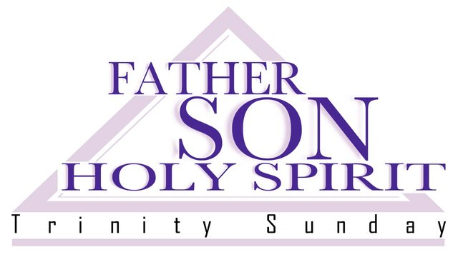

** Looking Ahead on the Calendar **
Monday, 6/8 | 7:00 p.m. | Wesleyan Group @ Jane White’s home.
Sunday, 6/14 | 10:00 a.m. | Choir
GRADUATES
Graduation is upon us. Let the church office know if you, or a
family member, will be graduating this year. You can call us at 239-8423 or email us at chestnuthillumc@comcast.net.
Birthdays Coming Up: May 31-Dean Burgess.
June 1-June Crickenberger. 5-Erin Long. 8-Vernelle Roupe. 12-Frances Unruh
For the Grocery Cart:
June ~ Chunky Soups, Fruit/Vegetable Canned Goods. Pop-top.

